Wednesday 10th February – Maths
Watch the Youtube video then complete the tasks below:

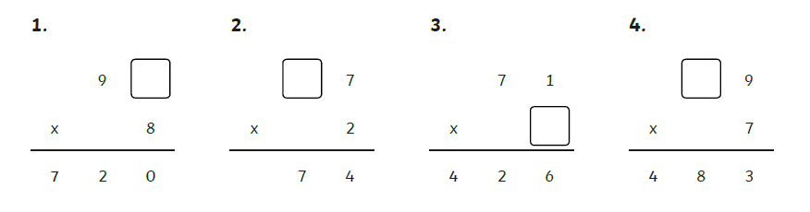

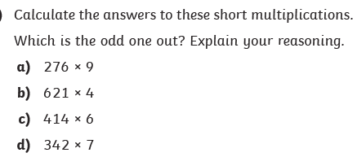

Which child did which calculation? Write a sentence for each to explain how you know

