Tuesday 6th July.

Physical Education.
Good Morning!
Let’s start off with a warm up to get ourselves ready.
https://www.youtube.com/watch?v=H1zuAsoGpl4
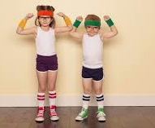

Now you have warmed up, let’s go on a bear hunt!
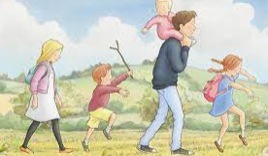

https://www.youtube.com/watch?v=KAT5NiWHFIU

Don’t forget to drink water after exercising and rest when you need to.

