Monday 5th July.
Science: WALT: Name and identify carnivores, herbivores
and omnivores.

You have already grouped animals into fish, amphibians, birds, mammals and reptiles categories.
This week we are going to learn about how to identify animals by what they eat. We are going to learn about carnivores, herbivores and omnivores.
Watch the clip. https://www.youtube.com/watch?v=3yrikH2QEFA
Have the animals below got the right food for them? Match them up correctly.
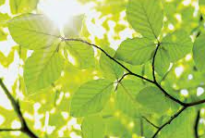
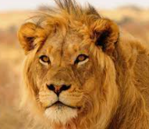

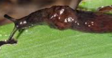
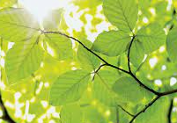
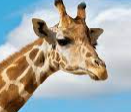

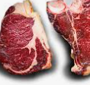
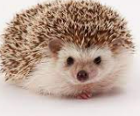

Watch the clip below to check if you are right and find out more about omnivores, carnivores and herbivores.
https://www.bbc.co.uk/bitesize/clips/zwfd2p3

Activity.
Using a piece of paper can you make a restaurant menu for a carnivore, a herbivore and an omnivore?
What would a hedgehog have for a starter? For their dinner and then for their pudding? Draw a picture of each animal you have chosen and don’t forget to make sure you have the right animal in the right group. A giraffe will not eat small rodents or insects! Here is my menu for an omnivore.
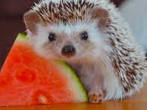
Omnivore menu.

Starter; melon slices
apple pieces
beetles

Main course: earwigs
fallen eggs from birds nests
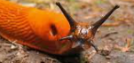
millipedes

Pudding: worms
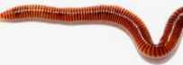
caterpillars
slugs

Have fun, scientists! Don’t forget to use your best handwriting and phonics to help you.

