WC 5th July 2021

Art.
‘Van Gogh’. Have you ever heard of this famous artist?
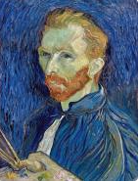
Vincent Van Gogh was famous for painting pictures with beauty, emotion and colour. Some of his most famous work is paintings of sunflowers. He has a museum named after him in Amsterdam where you can see many of his paintings.
Use this link to listen to a story about Camille and the Sunflowers.
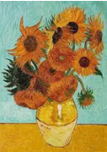
https://www.youtube.com/watch?v=3WD6n97L6G0
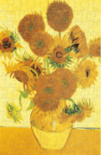
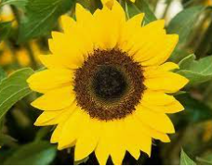
Now use your coloured pens or pencils and draw sunflowers. Or, you can choose a flower of your choice to draw. If you have a garden, look outside and draw some lovely flowers.
