Year 1 - W/C 05.07.21

English and Design and Technology
This week in English, our focus book is ‘’Busy Boats’, by Tony Mitton and Ant Parker. You will listen to the story and think about the different boats that you see. Your task will be to design your own boat, make it and then sail it to see if it will float. Have lots of fun! The tasks will be set in more detail on the video that will be uploaded onto YouTube on Monday, and are to be completed Tuesday to Friday.

Your task for Monday is detailed in this email.

Phonics
Remember to practise your Phonics every day at home. This week we will continue our focus on reading real and fake words. Two sets of Phonics Activity Mats. have been attached for you. There are 12 in each set so you can choose a different one each day.
You can also continue to practise reading real and fake words using www.phonicsplay.co.uk
These games will help you to practise reading real and fake words: The following links are all FREE to play

Picnic on Pluto - https://www.phonicsplay.co.uk/resources/phase/2/picnic-on-pluto
Dragons Den - https://www.phonicsplay.co.uk/resources/phase/2/dragons-den
Buried Treasure - https://www.phonicsplay.co.uk/resources/phase/2/buried-treasure

Please also use the Phonics videos that were uploaded onto the school YouTube channel during the last lockdown (February 2021). These are focusing on your Phase 5 sounds and will be great revision for you.

Year 1 – English
Monday 5th July 2021

WALT: I can combine words to form grammatically accurate sentences. I can join words and clauses using ‘and’.
CHALLENGE: I can sequence sentences to form a short narrative.
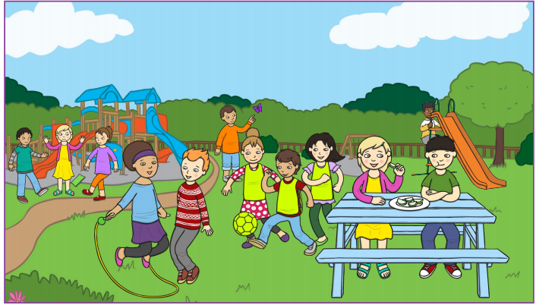

Activity 1
Look at the above picture. Discuss with your adult what can you see. What could you write about the picture?
Activity 2
Write some sentences or even a story, thinking about what you need to make your sentences correct. Think about your word choices. Do your word choices make your sentences more interesting for the reader?
Activity 3
Remember to read your work when you have finished to make sure it makes sense and that you have got the capital letters, finger spaces and full stops needed. Did you use ‘and’ as a joining word?

Year 1 – W/C 05.07.21 (Tuesday to Friday)
English and Design and Technology – Keeping Afloat
Your English and D&T challenge this week is to build a boat that can keep afloat. What do you know about boats? Have a think about what would be good materials to use to build your boat so that it will float.
How can you test your boat?
The tasks will be given to you in more detail on the video to be uploaded on Monday.
Ideas that you can use to help you:
How can I test the material to check it is waterproof?
Which design do you like best? Why?
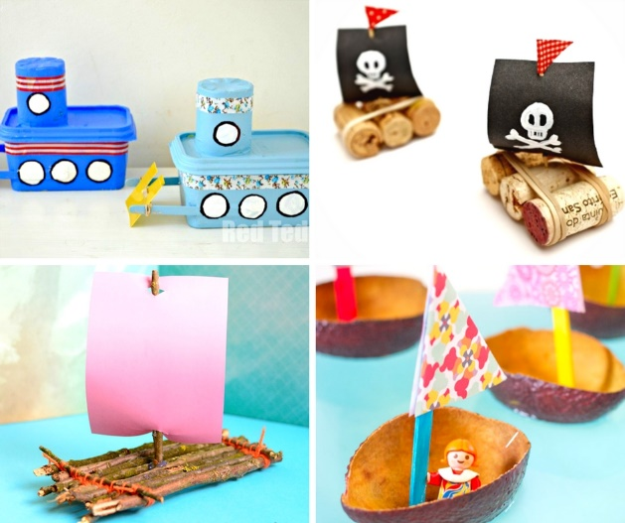
How can I fasten materials together?
When you have tested your boat, can you answer these questions?
What was it about your boat that worked well?
What would you change about your boat if you made it again?

