**Maths - Monday 5th July 2021**

WALT: I can compare length and height and use the appropriate vocabulary.

This week we are practising our measuring skills.

* The first step is to compare and discuss heights and lengths.
* The next step is to measure with non-standard units (objects that at the same size e.g. cubes, pasta shapes, building blocks etc).
* Finally, we move on to measuring standard units (cm/m) with rulers, metre sticks and tape measures.

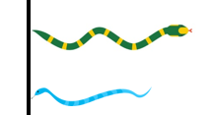

[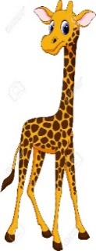](https://www.google.co.uk/url?sa=i&rct=j&q=&esrc=s&source=images&cd=&cad=rja&uact=8&ved=2ahUKEwilvf21l9XgAhU0RhUIHWWyDYcQjRx6BAgBEAU&url=https://www.123rf.com/photo_33879670_stock-vector-cute-giraffe-cartoon.html&psig=AOvVaw1TSYi9_hs3mFPgqYJ_fWoO&ust=1551125608438856)

**Lengths** are usually measured **sideways**, like the snakes.

[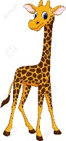](https://www.google.co.uk/url?sa=i&rct=j&q=&esrc=s&source=images&cd=&cad=rja&uact=8&ved=2ahUKEwilvf21l9XgAhU0RhUIHWWyDYcQjRx6BAgBEAU&url=https://www.123rf.com/photo_33879670_stock-vector-cute-giraffe-cartoon.html&psig=AOvVaw1TSYi9_hs3mFPgqYJ_fWoO&ust=1551125608438856)

**Heights** are measured **upwards**, like the giraffes standing on the ground.

**[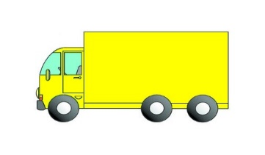](http://www.google.co.uk/url?sa=i&rct=j&q=&esrc=s&source=images&cd=&cad=rja&uact=8&ved=2ahUKEwjcw7bNm9XgAhULrxoKHX1qDWwQjRx6BAgBEAU&url=http://learnenglishkids.britishcouncil.org/tongue-twisters/red-lorry-yellow-lorry&psig=AOvVaw02HonGDx3wMFeSiV9ARHSi&ust=1551126755889389)Same as**

Some objects may be the same length or height like these lorries.

[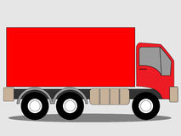](https://www.google.co.uk/url?sa=i&rct=j&q=&esrc=s&source=images&cd=&cad=rja&uact=8&ved=2ahUKEwjxisKBnNXgAhVDOhoKHa7OB90QjRx6BAgBEAU&url=https://www.dreamstime.com/stock-illustration-red-truck-lorry-illustration-advertising-text-image-may-be-added-image-image47086259&psig=AOvVaw1uRkOBn0cX6V3yFnStS1HI&ust=1551126856550195)

The yellow lorry is the **same** length as the red lorry.

**Activity 1**

Find pairs of objects around your home to compare and see which is the shorter of the two and which is the longer?

Look at pairs of people in your family or pairs of toys and compare who is taller and who is shorter?

Find two of your toys that are the same length or height.

***Important note***

When comparing lengths or heights, make sure one end of each object is lined up. You can then compare the other end to see which is longer. The paintbrushes in picture A are not lined up at one end, so cannot be compared. The ends of the paintbrushes in picture B are lined up and so we can clearly see that the yellow one is shorter.

A B

**Activity 2**

Complete the sentences below. Use the following words **shorter taller longer**

****The man is _______ than the boy.

The boy is ________than the man.

[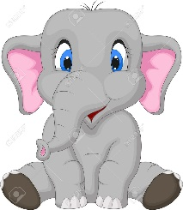](https://www.google.co.uk/url?sa=i&rct=j&q=&esrc=s&source=images&cd=&cad=rja&uact=8&ved=2ahUKEwjD8p3UlNXgAhXQQxUIHaezAfMQjRx6BAgBEAU&url=https://www.123rf.com/photo_23006598_cute-elephant-cartoon-sitting.html&psig=AOvVaw19WAKazgvghund38xoWR2p&ust=1551124890814470)

[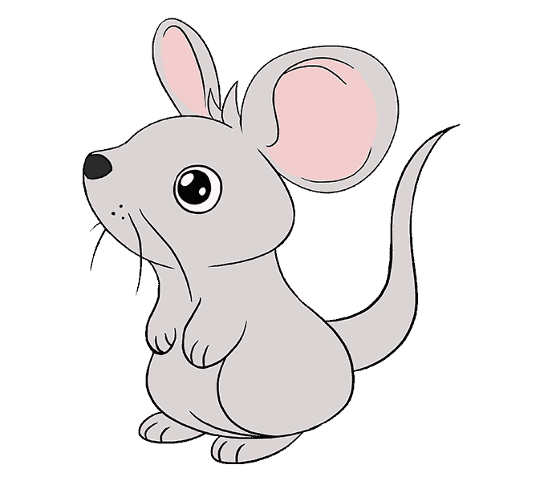](https://www.google.co.uk/url?sa=i&rct=j&q=&esrc=s&source=images&cd=&cad=rja&uact=8&ved=2ahUKEwi29fSZlNXgAhXMRRUIHX8MBPwQjRx6BAgBEAU&url=https://easydrawingguides.com/how-to-draw-a-mouse/&psig=AOvVaw2l4oqr0FWW9PIbgY8dxUKH&ust=1551124761346543)The mouse is _______ than the elephant.

The elephant is _______ than the mouse.



The blue pencil is ________than the orange pencil.

The orange pencil is ______than the blue pencil.

[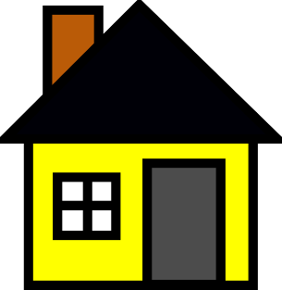](http://www.google.co.uk/url?sa=i&rct=j&q=&esrc=s&source=images&cd=&cad=rja&uact=8&ved=2ahUKEwiDvKjqmNXgAhUVUhUIHX_zAbIQjRx6BAgBEAU&url=http://www.clker.com/clipart-yellow-house.html&psig=AOvVaw16DSgs8ZGxAMQ5kgmAZfHS&ust=1551126008753756)

[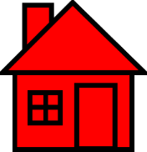](http://clipart-library.com/red-house-cliparts.html)

The red house is _______ than the yellow house.

The yellow house is ________than the red house.

[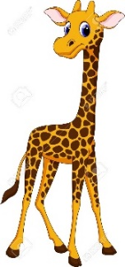](https://www.google.co.uk/url?sa=i&rct=j&q=&esrc=s&source=images&cd=&cad=rja&uact=8&ved=2ahUKEwilvf21l9XgAhU0RhUIHWWyDYcQjRx6BAgBEAU&url=https://www.123rf.com/photo_33879670_stock-vector-cute-giraffe-cartoon.html&psig=AOvVaw1TSYi9_hs3mFPgqYJ_fWoO&ust=1551125608438856)

[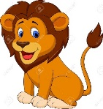](https://www.google.co.uk/url?sa=i&rct=j&q=&esrc=s&source=images&cd=&ved=2ahUKEwjYjcr4l9XgAhUEsXEKHSi0At8QjRx6BAgBEAU&url=https://www.123rf.com/photo_19287800_funny-lion-cartoon.html&psig=AOvVaw1EoIa7kiPhFQVhcjkrzapX&ust=1551125693018339)The giraffe is _______ than the lion.

The lion is ________than the giraffe.

[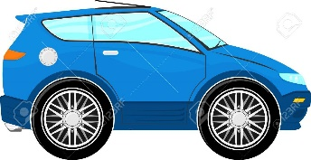](https://www.google.co.uk/url?sa=i&rct=j&q=&esrc=s&source=images&cd=&cad=rja&uact=8&ved=2ahUKEwiggr6bltXgAhUlSRUIHYmCB4wQjRx6BAgBEAU&url=https://www.123rf.com/photo_20358629_funny-blue-car-cartoon-isolated-on-white-background.html&psig=AOvVaw2s8K6Vqteg8oxjjTt-ejvf&ust=1551125304017999)

[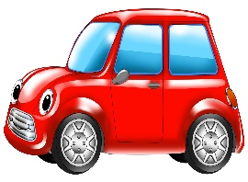](https://www.google.co.uk/url?sa=i&rct=j&q=&esrc=s&source=images&cd=&cad=rja&uact=8&ved=2ahUKEwiYvKy7ltXgAhVlQhUIHQKvBHIQjRx6BAgBEAU&url=https://jooinn.com/red-car-4.html&psig=AOvVaw3OsdqlpXwiEB60W5yKHTuV&ust=1551125360748750)The red car is ________than the blue car.

The blue car is ______than the red car.

**Activity 3** (to be done if/when your child is secure with activity 2 and 3)

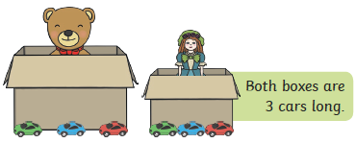

Jem used her cars to measure the boxes.

She says they are both 3 cars long. Is she correct? **Explain** your answer.

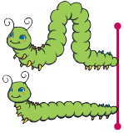

Are the caterpillars the same length.

How do you know?

**Explain** your answer.

Choose the correct work from the word bank to create your own sentence to compare the height of the two houses.

|  |  |  |
| --- | --- | --- |
| longer | taller | higher |
| long | equal | smaller |
| shorter | small | same |

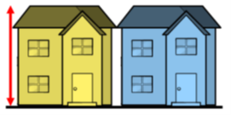

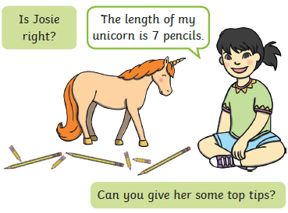

Optional tasks

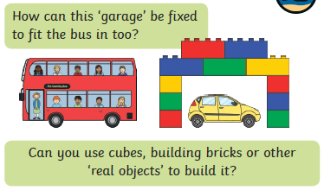Write a list of equipment we can use to measure length and/or height.