Wednesday 7th July.
Physical Education.

Today we are going to do Yoga!

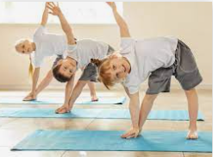
https://www.youtube.com/watch?v=23VdtT0vQUY

You can still be sporty even though you cannot go to the park.
- Have you got stairs? Run up them 4 or 5 times. Go careful to walk back down though!
- Have you got a small ball? Throw it up in the air and practice your catching.

