WC 5th July 2021.
History.
Can you remember when we walked around the school looking at the old building and the new buildings? We talked a lot about things that were different and what it might have been like to go to school when it first opened in 1907 and then again in the 1940’s and 50’s.
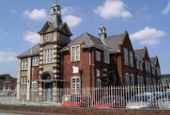
This was the original school.
Today, we are going to think about what Ferndale school would have been like in 1950 as Barbara (our local vicar) will be able to zoom call us soon and answer these questions, as she went to Ferndale School during this period!
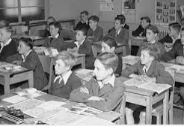

You are going to write a list of questions that you would like to ask Barbara. I have thought of two questions to start you off.
- What time did school start and finish?
- What lessons were taught?
Good luck, Historians! We can invite Barbara to a zoom call soon.

