Monday 5th July;
Physical Education.

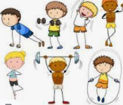
It is sports week this week and although you are not at school, you can still exercise and have fun!

Every day, have a gentle stretch of your body and move all your body parts to warm up your body before exercising.

Use this link to move your body and exercise.
https://www.youtube.com/watch?v=DqAOMrZkht0&list=PLoOc9M0VgduMnQiJ56Gw5TX7wsGIF7kmv&index=5

Don’t forget you can exercise anywhere, but remember to be careful and don’t bump into things! If you can, use Go Noodle as well to have a dance!
See you tomorrow for some more sports fun!
