Thursday 8th July.

Physical Education.

Today is about dancing and balancing!
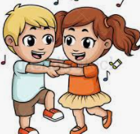

https://www.youtube.com/watch?v=ERbdjlvg6dg
https://www.youtube.com/watch?v=KhfkYzUwYFk

Try to keep your balance with the next clip and go careful you don’t bump your head with the tricky poses!
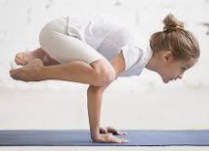

https://www.youtube.com/watch?v=zMHOgzFTPSg

