Friday 9th July.

Physical Education.

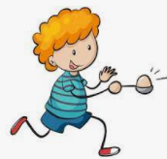
Go and find a spoon and something to balance on it, maybe a small bouncy ball or something round. Walk around your home without losing the ball off your spoon! Maybe time yourself and try and get faster.
Good luck!

Make an obstacle course in one room in your home, be sure to ask first! https://www.youtube.com/watch?v=v7V_uKNvxvk
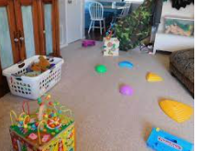
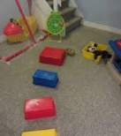

https://www.youtube.com/watch?v=xhWDiQRrC1Y Use this link if you are not able to make an obstacle course. Have fun!

