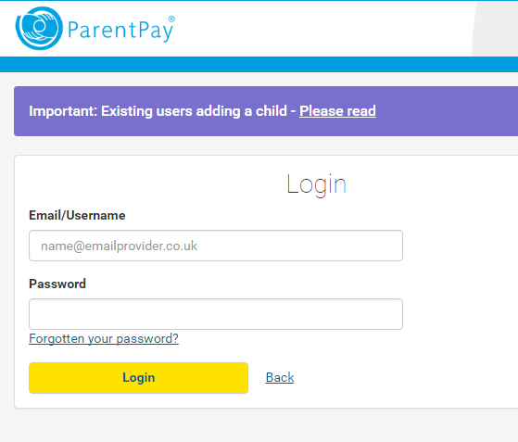
How to book your After School Sessions
Log on to www.parentpay.com using the username and password given in your Registration letter.

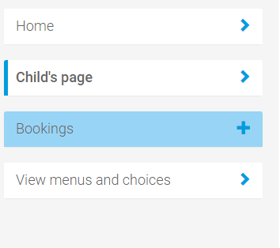
Select the child you wish to book for

Select ‘Bookings’ from the left hand menu, then ‘make or view bookings’
Booking Type
- Afternoon = 3.30-4.30 (Mon-Thu)/
2.00-3.00pm (Friday)
- After School = 3.30-6.00 (Mon-Thu)/3.00-6.00pm (Friday)
- (Please add both sessions for Friday if your child is staying after 3pm)
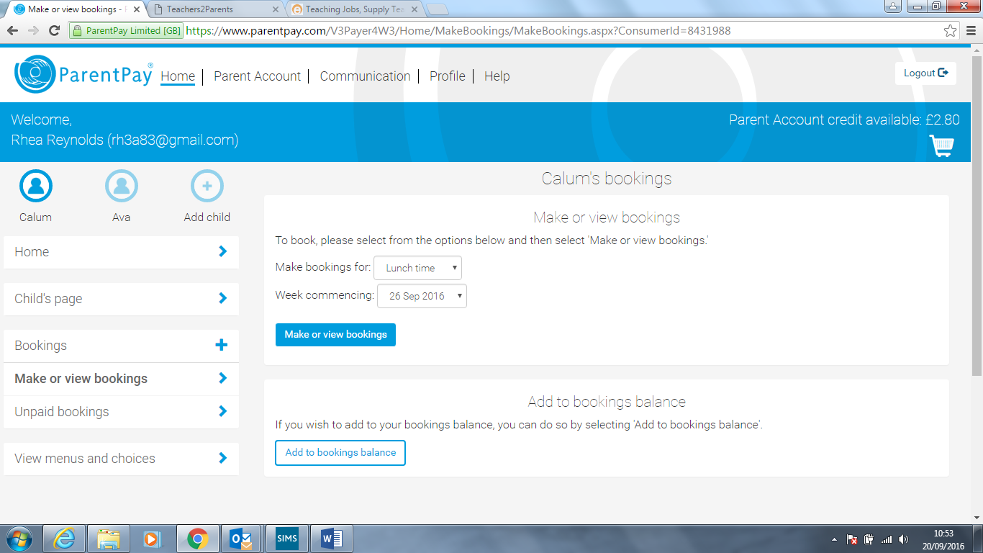
Select the session and week you require from the drop down menu, then select
From the next screen you can then choose the days you wish to book by clicking and turning them green.
Once you have finished selecting, scroll to the bottom of the screen and select ‘confirm booking
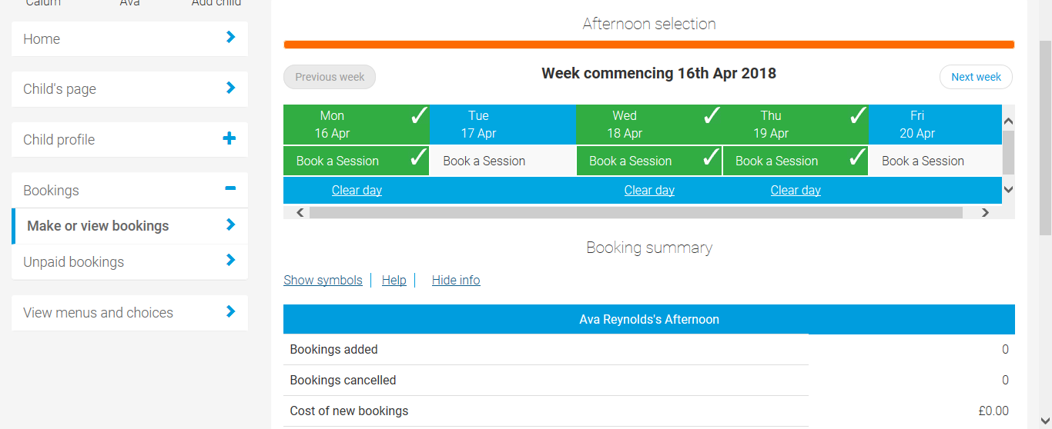
We have a maximum number of places on offer each day and we are unable to exceed the maximum number to ensure we meet all health & safety requirements. Places are offered on a first come first served basis. For this reason, we must insist that payment is made at the time of booking. The latest that a session can be booked and paid for is Wednesday of the week before the place is required.
Extra-curricular clubs will still take place each day, from 3.30-4.30pm Monday to Thursday and 1pm-2pm on Fridays, so please ensure you bear this in mind when booking your child’s place.
Cancellations must be made at least 48 hours before the day the child is booked in for, by emailing admin@ferndale.swindon.sch.uk. The full session fee will be charged if a child booked for the club does not arrive or where less than 48 hour notice is given. If your child is unwell and not in school on the day they are meant to attend After School Club, your account will be credited.
If you have any queries, please contact Rhea Reynolds in the school office or email reynoldsr@ferndale.swindon.sch.uk

