FERNDALE PRIMARY AND NURSERY SCHOOL

Uniform
Policy

Ratified by Governing Body: September 2022
Reviewed Date: September 2022
Next Review Date: September 2025

Contents

- Aims
- Legal Duties
- Limiting the cost of school uniform
- Expectations for school uniform
- Expectations for our school community
- Monitoring arrangements
- Links to other policies

1. AIMS

This policy aims to set out our approach to requiring a uniform that is of reasonable cost and offers the best value for money for our parents and carers. It also aims to explain how we will avoid discrimination in line with our legal duties under the Equality Act 2010.

We will be clarifying our expectations for school uniform.

2. LEGAL DUTIES

The Equality Act 2010 prohibits discrimination against an individual based on the protected characteristics, which include sex, race, religion or belief and gender reassignment.

To avoid discrimination, our school will:
- Avoid listing uniform items based on sex, to give all pupils the opportunity to wear the uniform they feel most comfortable in or that most reflects their selfidentified gender
- Make sure that our uniform costs the same for all pupils
- Allow all pupils to have long hair (though we reserve the right for this to be tied back)
- Allow all pupils to style their hair in the way that is appropriate for school yet makes them feel most comfortable
- Allow pupils to request changes to swimwear for religious reasons
- Allow pupils to wear headscarves and other religious or cultural symbols
- Allow for adaptions to the policy on the grounds of equality by asking pupils or their parents to get in touch with the headteacher who can answer questions about the policy and respond to any requests

3. LIMITING THE COST OF SCHOOL UNIFORM

Our school has a duty to make sure that the uniform we require is affordable, in line with statutory guidance from the Department for Education on the cost of school uniform.

We understand that items with distinctive characteristics (such as branded or items with the school logo on) cannot be purchased from a wide range of retailers and that requiring many such items limits parents ability to “shop around” for a low price.

We will make sure our uniform:
- Is available at a reasonable cost
- Provides the best value for money for parents/carers

We will do this by:
- Carefully considering whether any distinctive characteristics are necessary
- Limiting any items with distinctive characteristics
- Limiting items with distinctive characteristics to low-cost or long-lasting items, such as ties
- Considering cheaper alternatives to school branded items, such as logos that can be ironed on, as long as this doesn’t compromise quality and durability
- Keeping the number of optional branded items to a minimum, so that the school’s uniform can act as a social leveller
- Avoiding different uniform requirements for different years/houses/classes
- Avoiding different uniform requirements for extra-curriculur activities
- Considering alternative methods for signalling differences in groups for interschool competitions, such as creating posters or labels
- Making sure that arrangements are in place for parents to acquire second hand uniform items
- Avoiding frequent changes to uniform specifications and minimising the financial impact on parents of any changes
- Consulting with parents and pupils on any proposed significant changes to the uniform policy and carefully considering any complaints about the policy

4. EXPECTATIONS FOR SCHOOL UNIFORM

4.1 Our School Uniform
Green (can be branded or plain) jumper or cardigan

White Polo Shirt/shirt

Black/Grey - skirt/dress or trousers
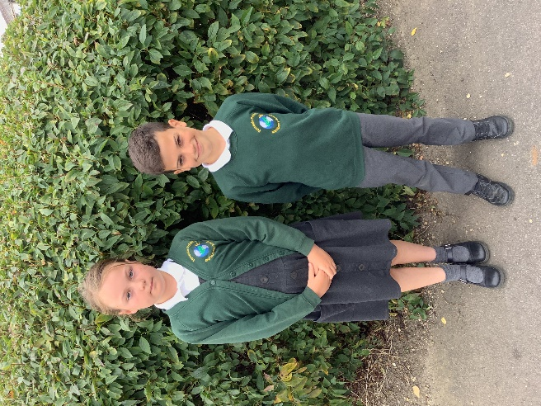
Black shoes/black trainers with no markings

Earrings should be studs only

Long hair should be tied back on PE Days

Hair should be a natural colour

There is no expectation for particular school bags or coats – we do ask that all items of clothing/bags are named.

4.2 Our PE Kit

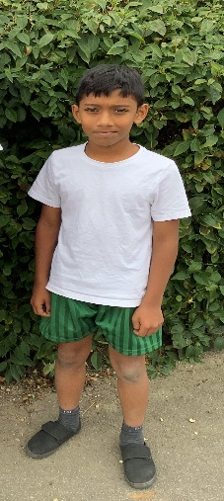
Green (can be branded or plain) jumper or cardigan
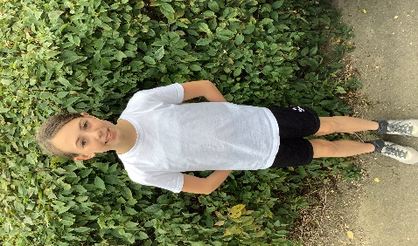
House colour polo shirt/t-shirt
Black/Green leggings/jogging bottoms and shorts for the summer
Any trainers
Earrings must be removed or covered

4.3 Where to purchase uniform

You can purchase the standard unbranded uniform from any high street store or supermarket. If you wish to purchase a branded cardigan/jumper we have a very reasonable supplier whose contact details can be found on the school website.

We have a small level of second-hand uniform which can be purchased via the school office at a reduced cost.

5. EXPECTATIONS FOR OUR SCHOOL COMMUNITY

5.1 Pupils
Pupils are expected to wear the correct uniform at all times (other than specified non-school uniform days) while:

- On the school premises
- Travelling to and from school
- At out of school events or on trips that are organised by the school, or where they are representing the school (if required)

Pupils are also expected to contact the headteacher, via the school office, if they want to request an amendment to the uniform policy in relation to their protected characteristics.

5.2 Parents and Carers
Parents and carers are expected to make sure their child has the correct uniform and PE kit, and that every item is:

- Clean
- Clearly labelled with the child’s name
- In good condition
Parents are also expected to contact the headteacher, via the school office, if they want to request an amendment to the uniform policy in relation to:

- Their child’s protected characteristics
- The cost of the uniform

Parents are expected to lodge any complaints or objections relating to the school uniform in a timely and reasonable manner.

Disputes about the cost of the school uniform will be:

- Resolved locally
- Dealt with in accordance with our school’s complaints policy

The school will work closely with parents to arrive at a mutually acceptable outcome.

5.3 Staff
Staff will closely monitor pupils to make sure that they are in correct uniform. They will give any pupils and families breaching the uniform policy the opportunity to comply, but will follow up with the headteacher if the situation doesn’t improve.

Ongoing breaches of our uniform policy will be dealt with by the headteacher in accordance with our behaviour policy.

In cases where it is suspected that financial hardship has resulted in a pupil not complying with this uniform policy, staff will take a mindful and considerate approach to resolving the situation.

5.4 Governors
The governing board will review this policy and make sure that it:
- Is appropriate for our school’s context
- Is implemented fairly across the school
- Takes into account the views of parents and pupils
- Offers a uniform that is appropriate, practical and safe for all pupils

This board will also make sure that the school’s uniform supplier arrangements give the highest priority to cost and value for money, for example by avoiding single supplier contracts and re-tendering contracts at least every 5 years.

6. MONITORING ARRANGEMENTS
This policy will be reviewed every 3 years.

7. LINKS TO OTHER POLICIES
This policy is linked to our:
- Behaviour policy
- Equality information and objectives statement
- Anti-bullying policy
- Complaints policy

